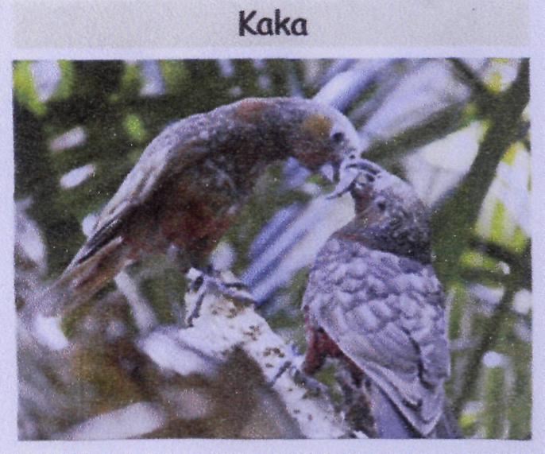
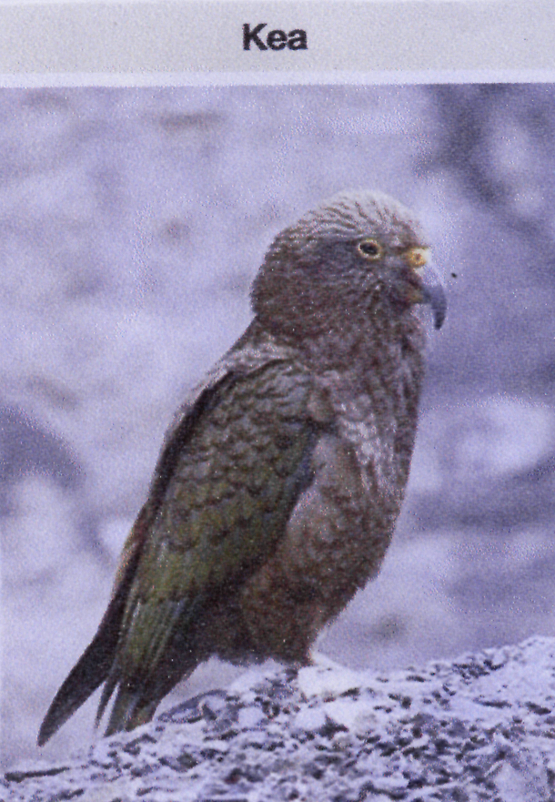
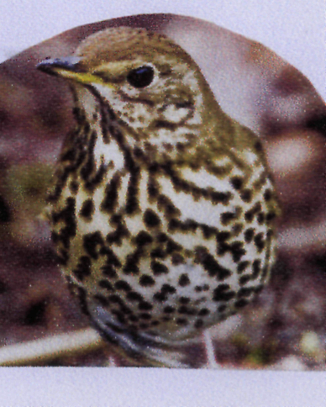

Parrot
Nest in hollows of trees Lays 2-4 eggs Eat fruits, berries seeds, flowers, nectar, grubs and buds off trees.

Parrot who lives in forests and Mountains. Curious bird!
Nest on ground under trees or rocks. Use moss, ferns and
rotten wood. Lays 2-4 eggs
Feeds on over 40 different plants, beetle larvae and any
thing else.

Imported from Europe-Song bird. Nests in trees uses many materials, coats the inside with mud. Love to smash snails on the ground and pulls worms from the ground.

